**Intelligent Vehicle Speed Control Based Upon Different Weather and Traffic Conditions**

* Introduction**:**

This project is for Embedded Systems class. It is about building a system for Intelligent Vehicles in which speed of the vehicle is controlled based upon different weather and traffic conditions. There is different weather sensors which send signals based upon weather conditions. In this project, the assumption is that we have 4 sensors namely rain sensor, snow sensor, ice sensor and fog sensor. The simulation will be implemented in Texas Instruments board. In the first step of the report literature review will be discussed on the Intelligent Vehicle Speed Control based upon different weather and traffic conditions. Second step will involve the requirements, third step will cover the design and finally the simulations. In the simulations it will be assumed that the sensors are transmitting data and based upon that, speed will be controlled and displayed on vehicle screen.

* Literature Review:

To determine a safe speed for vehicles, data must first be gathered on the conditions of the road. Different states in US have different road conditions due to different weather. As an example, in Michigan there is a lot of snow in winter which deteriorates road conditions. However, in California, weather is better, there is no snow in winter, so road conditions are much better. For this a combination of sensors on the road and above the road could be used. That’s why dynamics of a vehicle involves many things. In Michigan and many states this means collecting that data and determining the 85th percentile speed. This is the speed at which 85% of the vehicles stay at or below.

Speed Limits:

So now using the 70 mph as our baseline speed, we can determine the following appropriate speeds in this case:

• No snow, ice, or water present: Set speed to 70 mph

• Snow present: Set speed to 40 mph

* Rain present: Set speed to 50 mph

• Ice present: Set speed to 30 mph

• Fog present: Set speed to 35 mph

* Requirement:

1. Texas instrument chip.
2. Keil version 4.
3. Tera Term
4. Freescale board with switches.

* Design

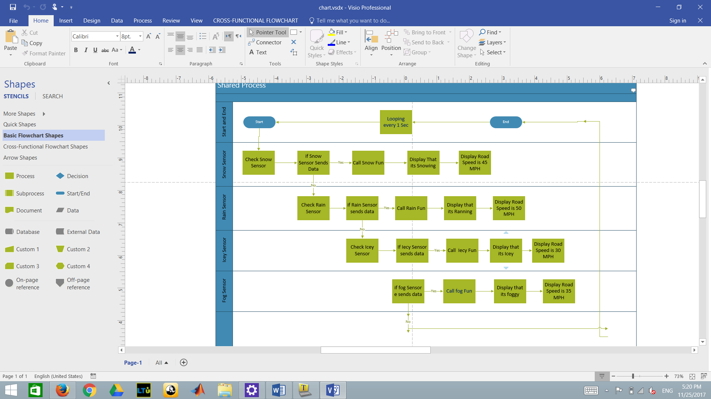

* Simulation Results:

The simulation results are shown as follows,

**Snow Sensor (switch)**

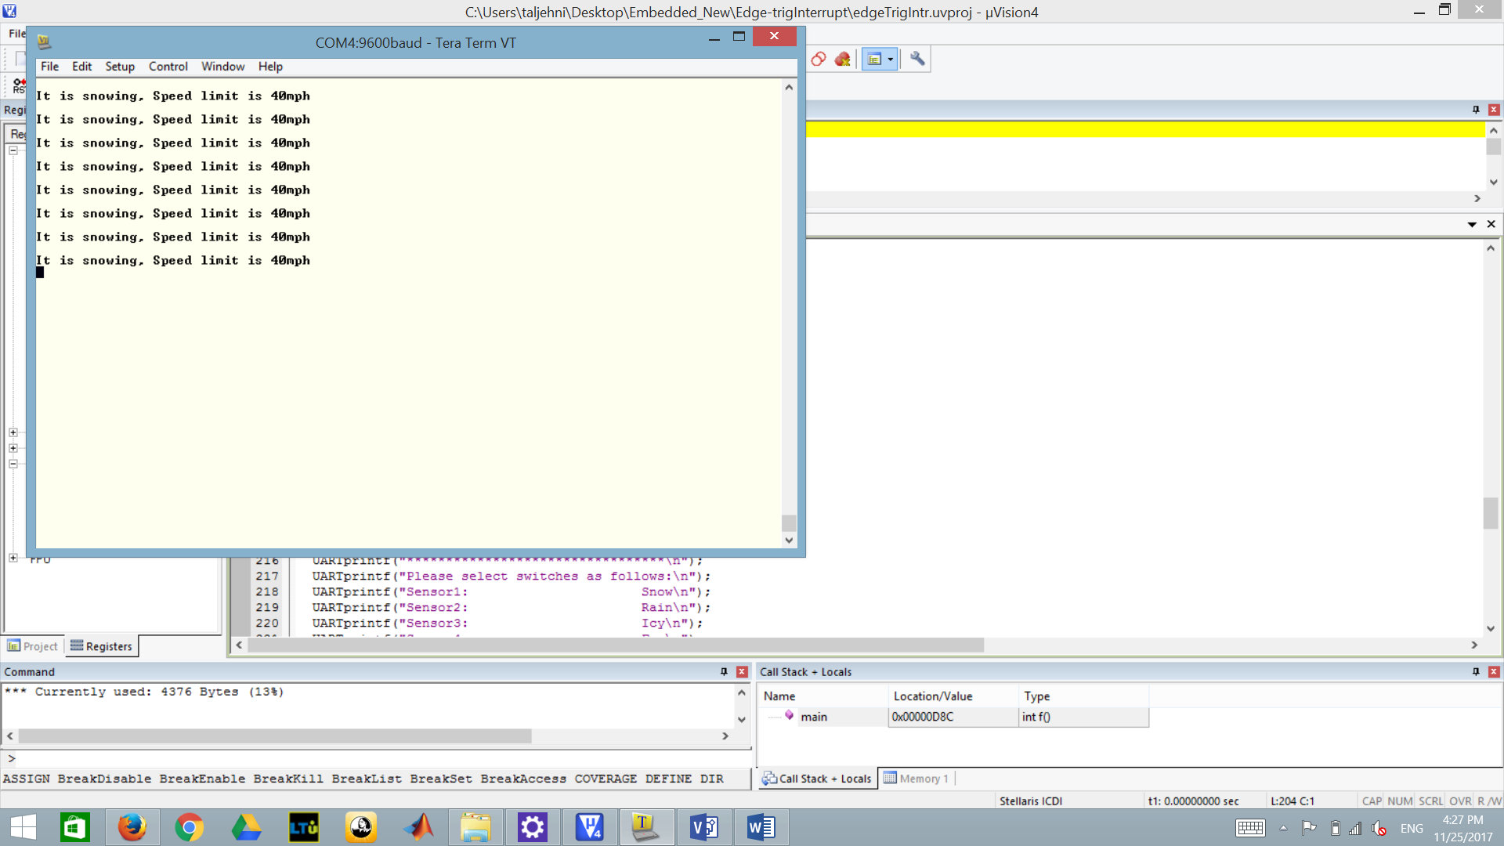

**Raining Sensor**

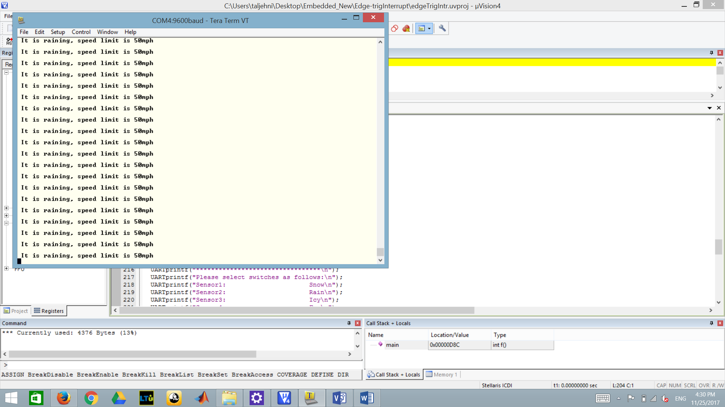

**Icey Sensor (switch)**

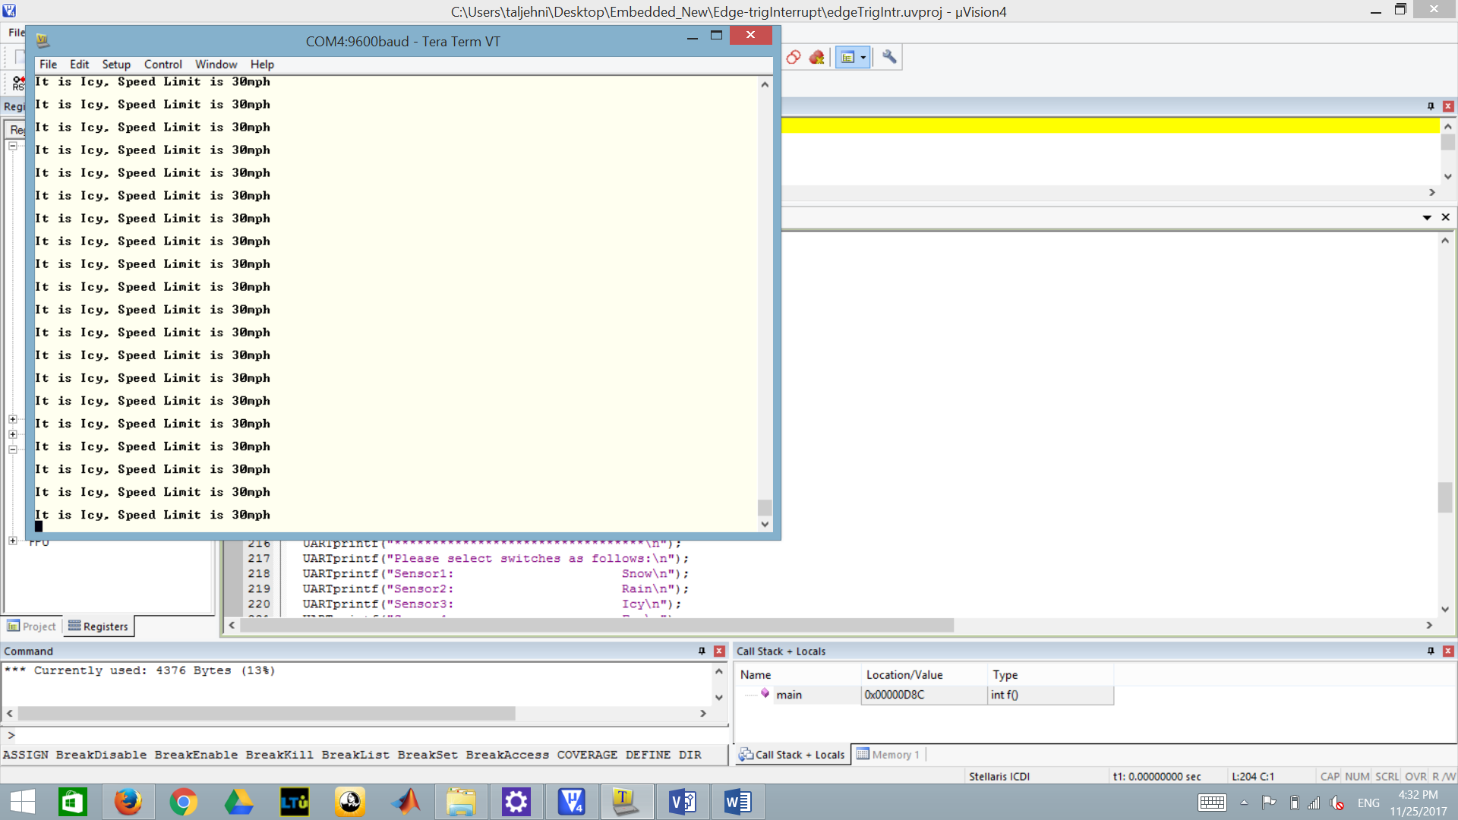

**Foggy Sensor (switch)**

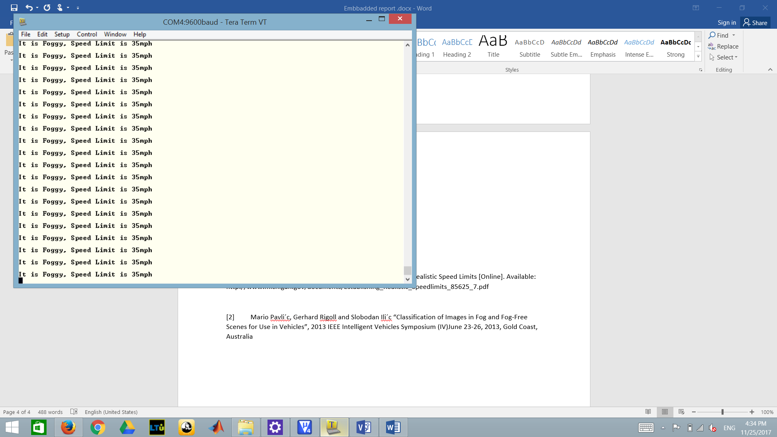

**No sensor is sending signal (All switches off)**

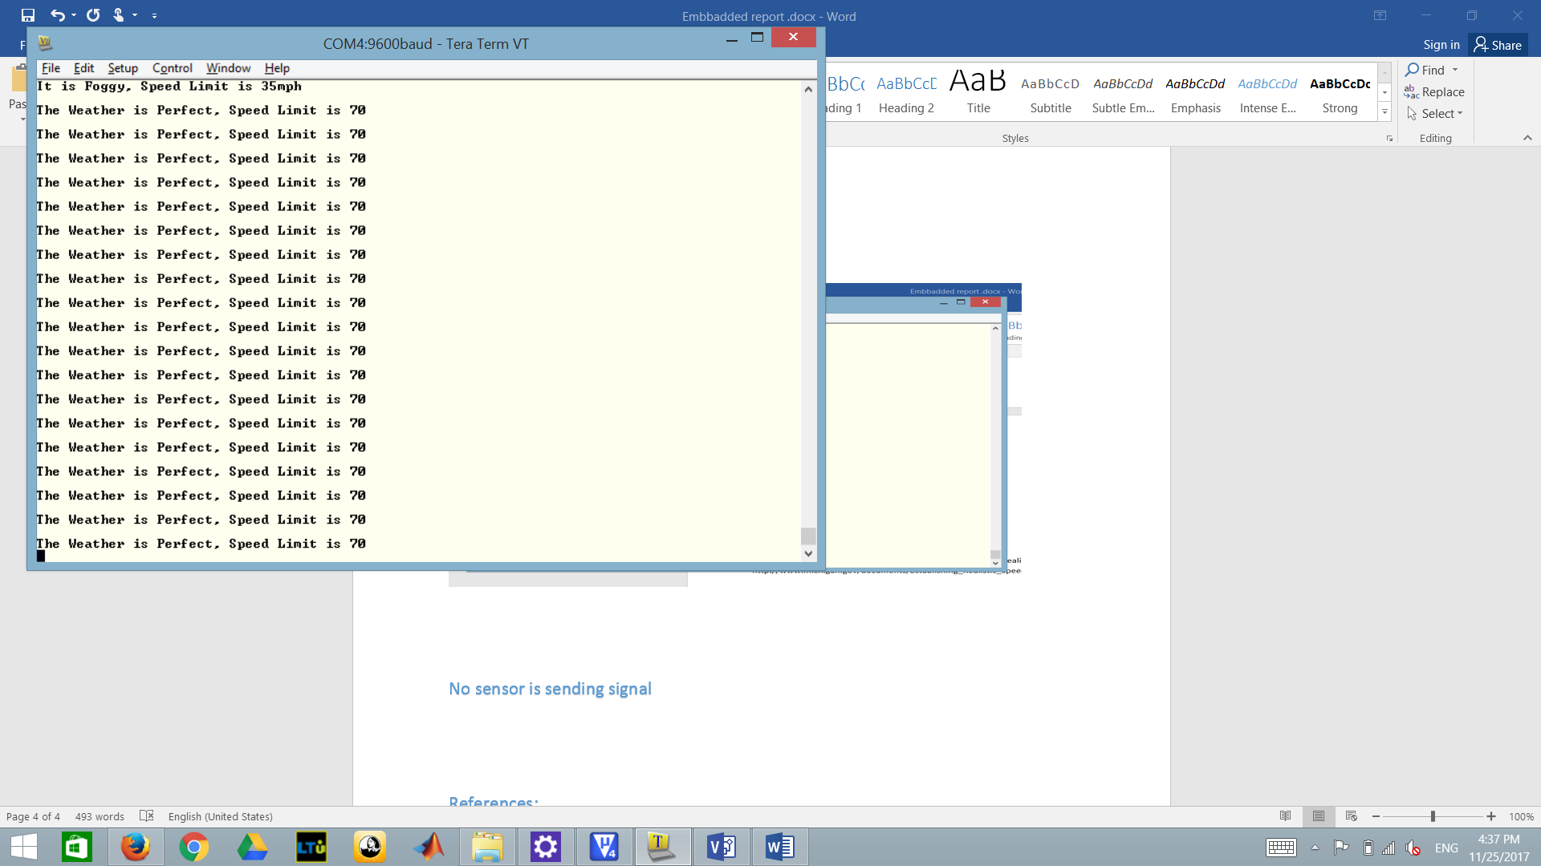

References:

[1] Michigan Department of Transportation. Establishing Realistic Speed Limits [Online]. Available: http://www.michigan.gov/documents/Establishing_Realistic_Speedlimits_85625_7.pdf

[2] Mario Pavli´c, Gerhard Rigoll and Slobodan Ili´c “Classification of Images in Fog and Fog-Free Scenes for Use in Vehicles”, 2013 IEEE Intelligent Vehicles Symposium (IV)June 23-26, 2013, Gold Coast, Australia

**Appendix**

* Presentation demo Video link:

<https://drive.google.com/drive/folders/1Ua5WytSq0KTLSk53l1ksfjkv6yIO6pf6?usp=sharing>

Note: presentation shows the following:

1. Hardware and software used in project.
2. The connection between the board and the chip.
3. The output for each configuration according to design.

* GitHub

.

The link for the uploaded project in githup as <https://github.com/Talaltj/FInal-Project>